**Colour Palette**

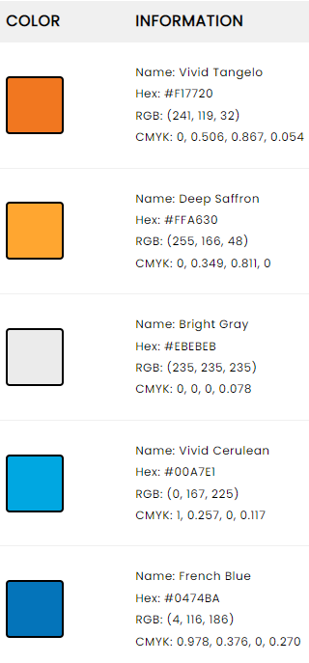 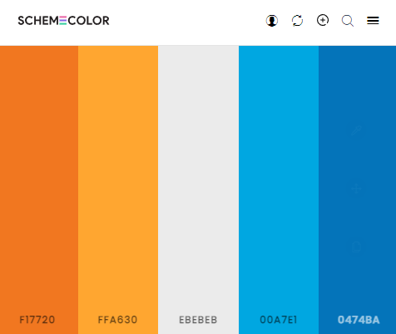

**Source : https://www.schemecolor.com/orange-and-blue.php**

**Font :** Verdana

**Logo Generator**

Ideas for the scheme colour

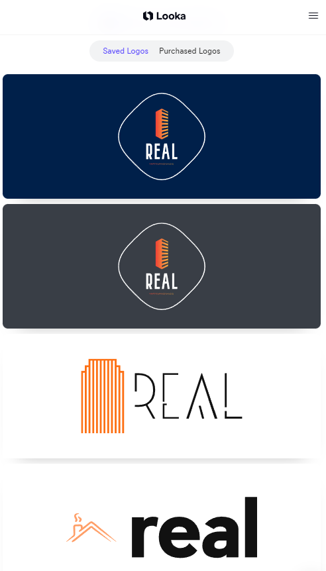 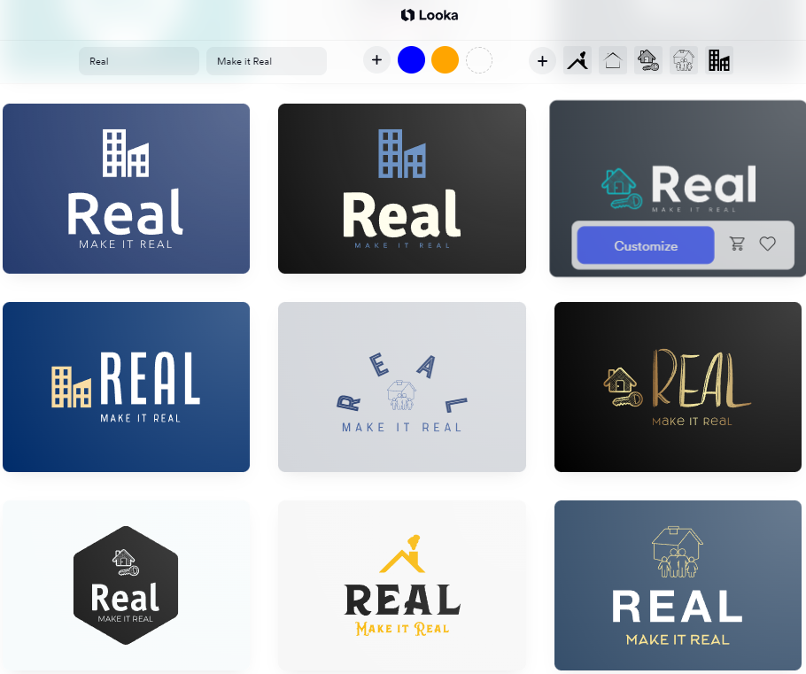

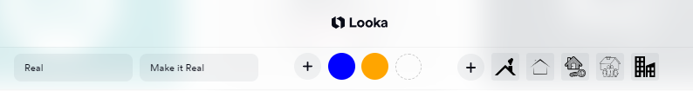

**Source :** https://looka.com**Competitor Market Research - Real Estate**

**Example 1 Website :** https://www.sherryfitz.ie/

The website is majority blue palette scheme colour. Also a responsive website and showing the properties in flexbox cards.

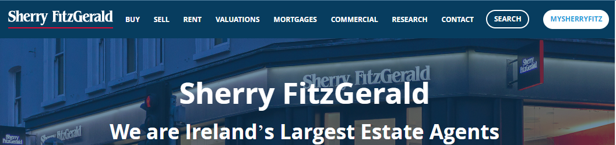

**Website Menu – scheme colour**

**Competitor Market Research - Real Estate**

**Example 1 Website :** https://www.sherryfitz.ie/

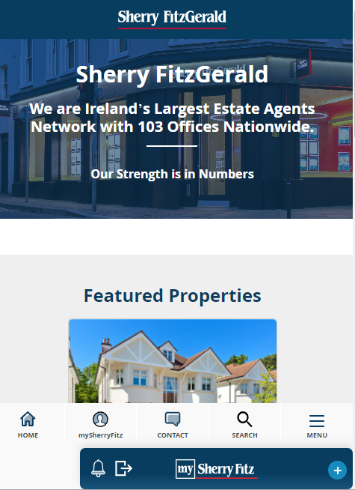 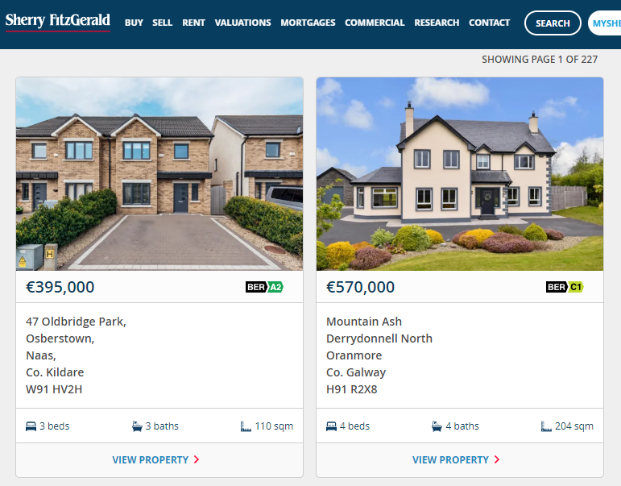 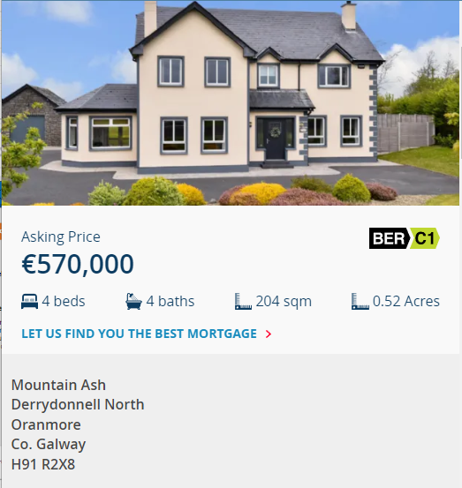

**House information**

**Web - 768px**

**Mobile view – 600px**

**Competitor Market Research - Real Estate**

**Example 2 Website :** https://www.daft.ie/ 

The website has a combination of blue and orange in their logo, also blue is part of their palette scheme colour.

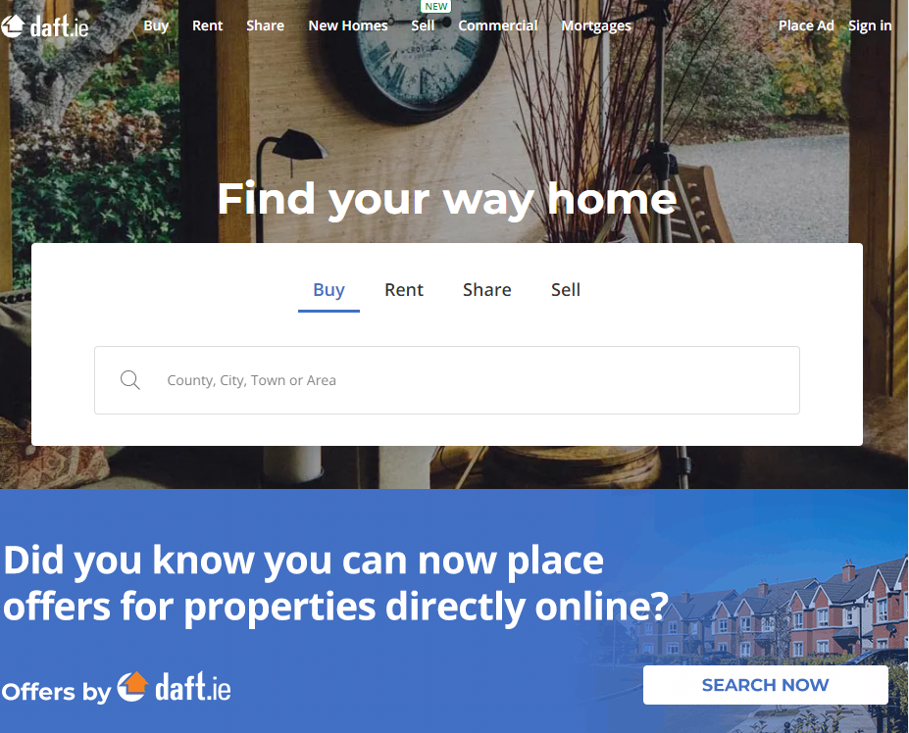 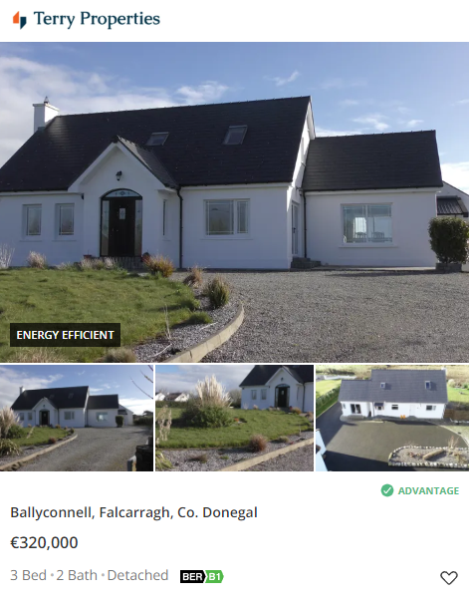

**Colour Emotions Palette**

*“…colour blue with words like Trust, Security and Reliability while yellow and orange are seen as colours which represent the word Cheap.”* Imtiaz, S. (2016).

Colour is not only a visual element of design, but it also plays an important role in how people perceive a brand or product. Different colours can evoke different emotions and associations in people. According to Sarosha's research on the psychology of web design, blue is commonly associated with reliability, trustworthiness, and security.

In contrast, yellow and orange are often associated with affordability and cheapness. Interestingly, the combination of blue and orange is powerful in real estate industry and communicates the message that reliable deals can be made. This shows that understanding the emotional nuances of colour can be a powerful tool for creating compelling visual communication.

Source:

Imtiaz, S. (2016). The Psychology Behind Web Design. [online] Available at: <https://www.researchgate.net/profile/Sarosha-Imtiaz/publication/312146392_The_Psychology_Behind_Web_Design/links/5871cb6c08ae329d62174266/The-Psychology-Behind-Web-Design.pdf> [Accessed 30 April 2023].

**Demonstration of the Website navigation by end user view**

1. **https://www.my-real-estate.com/Home**

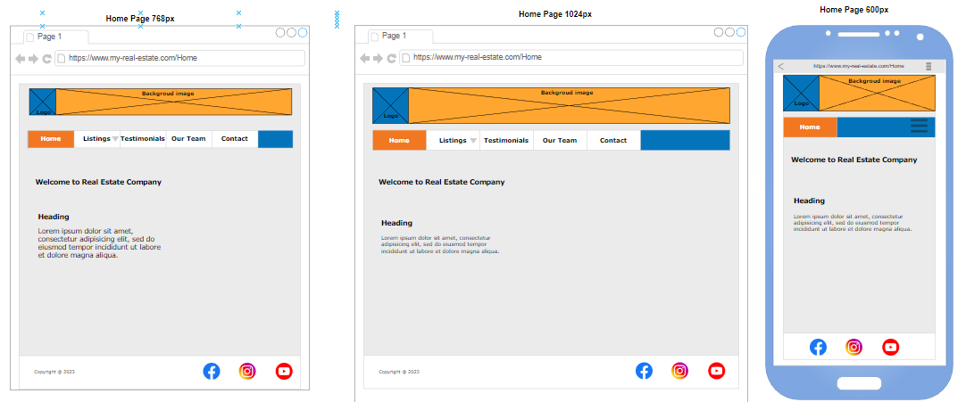

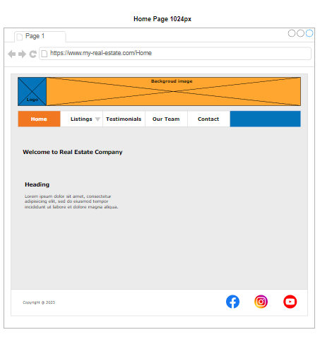

1. **https://www.my-real-estate.com/Listings**

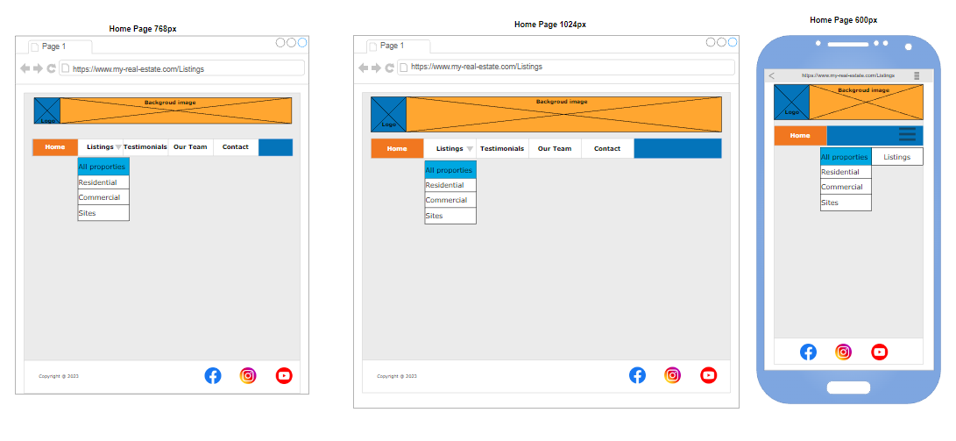

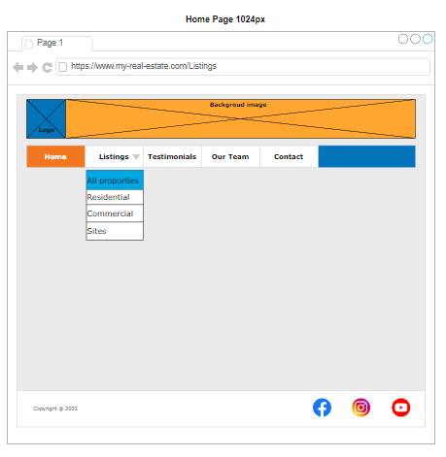

**2.1- https://www.my-real-estate.com/Listings/allproperties**

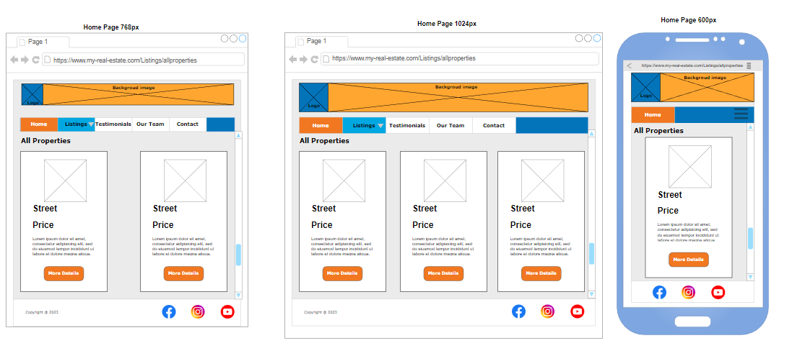

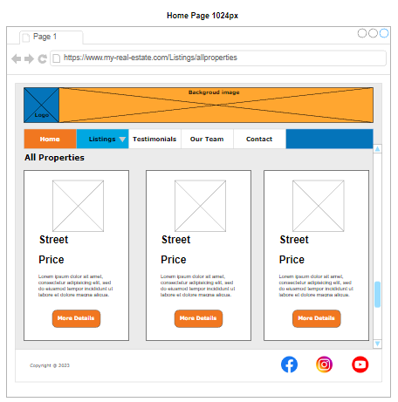

**2.2- https://www.my-real-estate.com/Listings/residential**

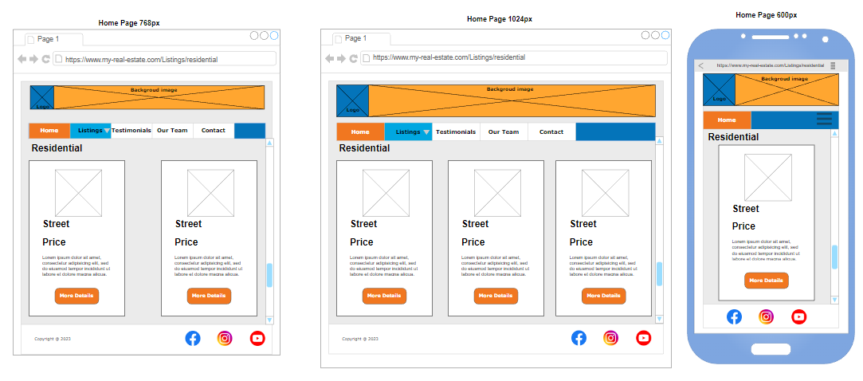

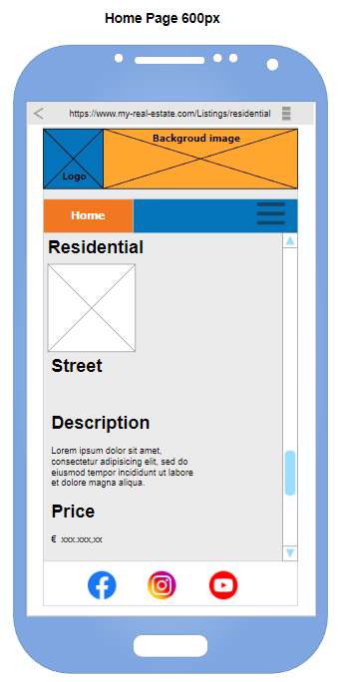

**2.3- https://www.my-real-estate.com/Listings/commercial**

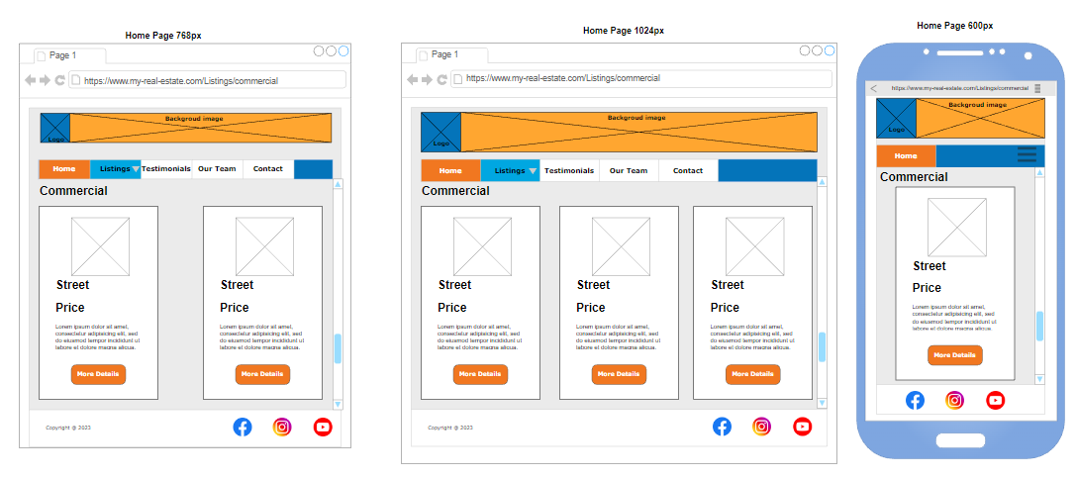

**2.4- https://www.my-real-estate.com/Listings/sites**

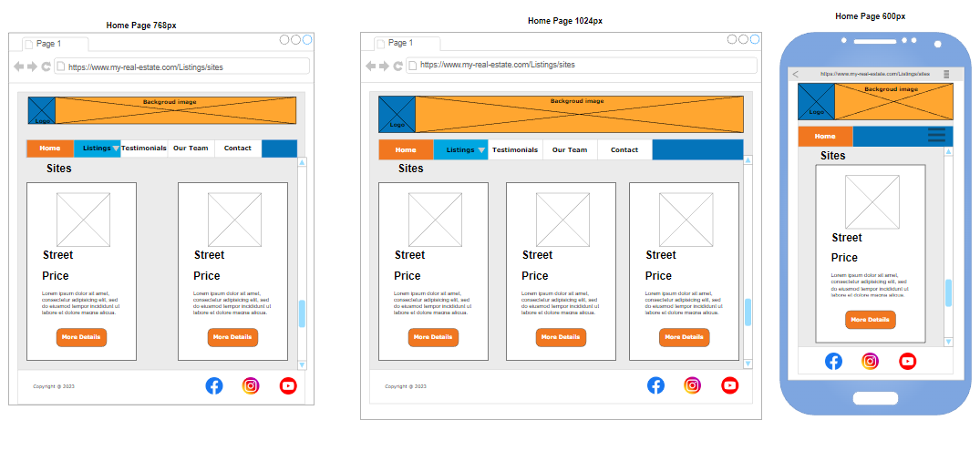

**3-https ://www.my-real-estate.com/Testimonials**

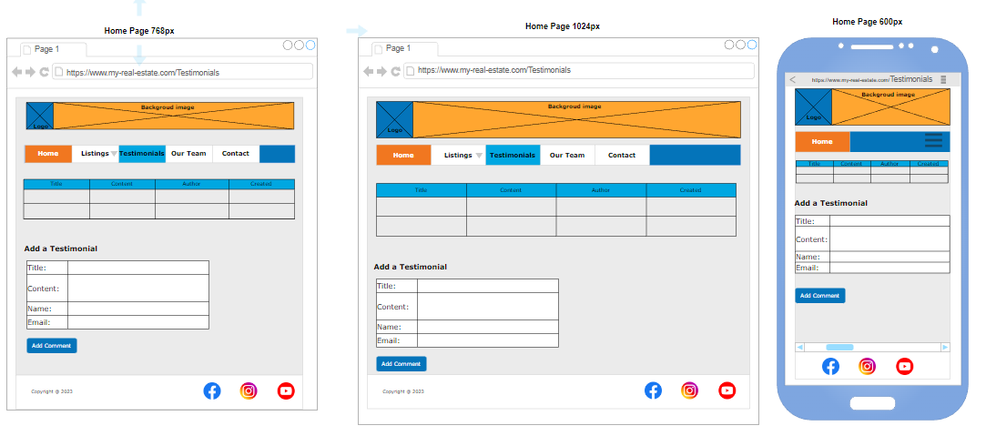

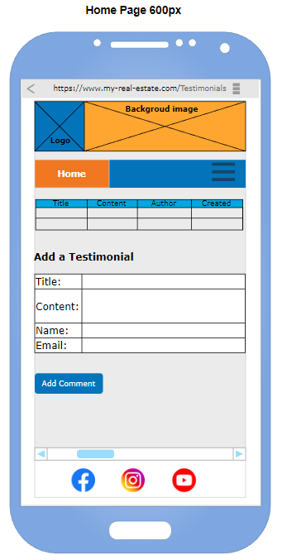

**4-https://www.my-real-estate.com/Ourteam**

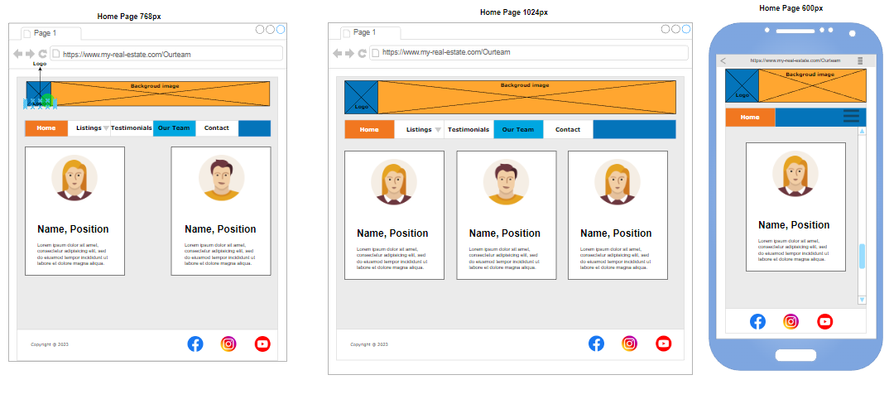

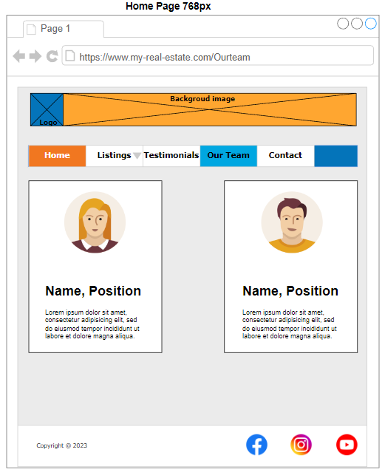

**5-https://www.my-real-estate.com/Contact**

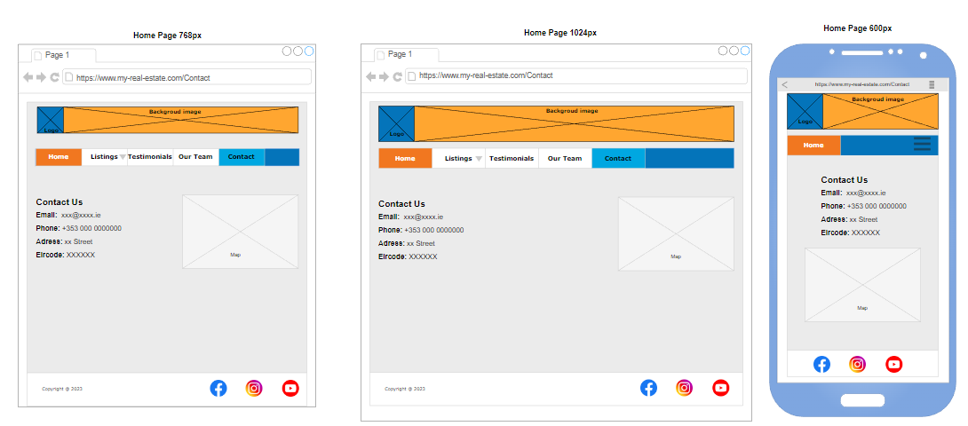

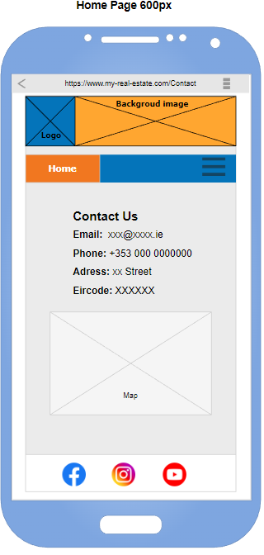

[**https://www.my-real-estate.com/Listings/residential/property1**](https://www.my-real-estate.com/Listings/residential/property1) **- part 1**

Each property single view is the same layout

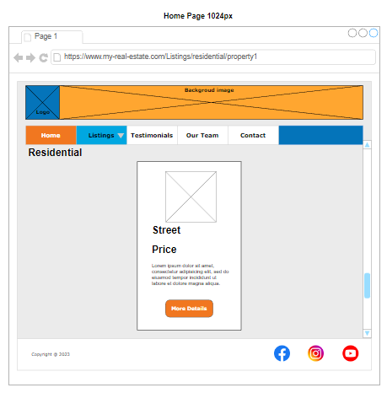

[**https://www.my-real-estate.com/Listings/residential/property1**](https://www.my-real-estate.com/Listings/residential/property1) **- part 2**

1024px – 768px – view is the same

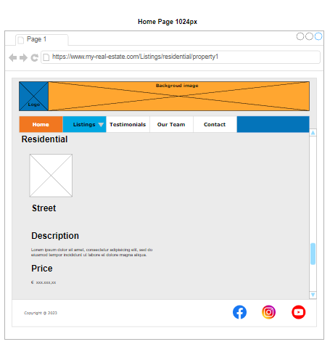

**https://www.my-real-estate.com/Listings/residential/property1 - part 3**

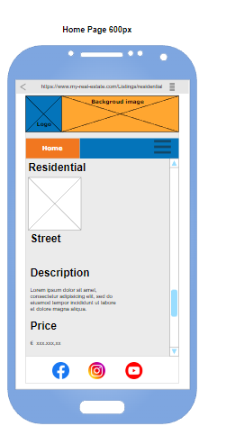

**Demonstration of the Website controlled by admin**

**Manage Products - http://localhost/.../manageproducts.php**

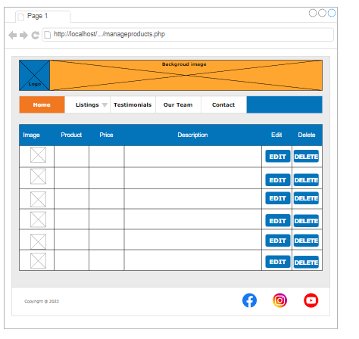

**Confirm Delete Property - http://localhost/.../ confirmdeleteproduct.php**

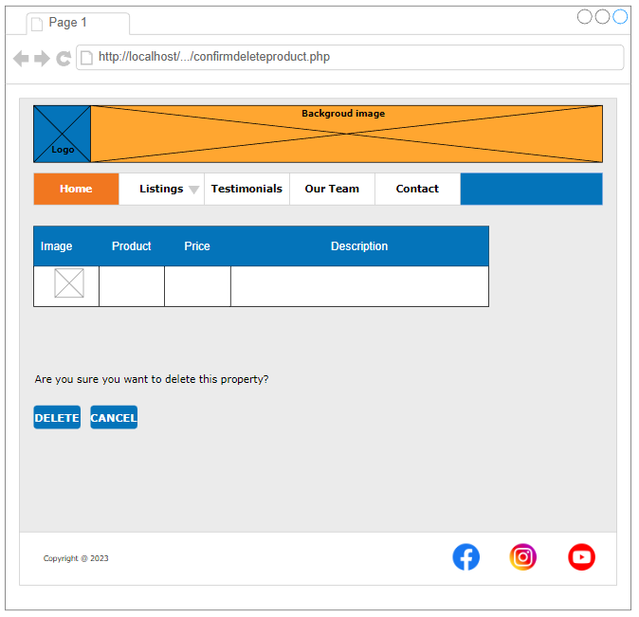

**Manage Properties - http://localhost/.../** **editproduct.php**

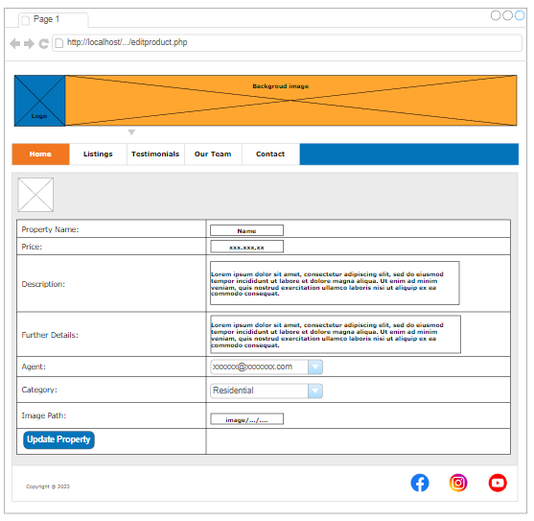

**Manage comments - http://localhost/.../ managecomments.php**

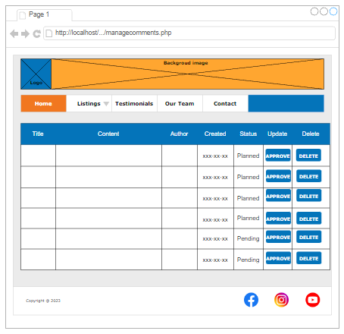

**Add Property - http://localhost/.../ addproduct.php**

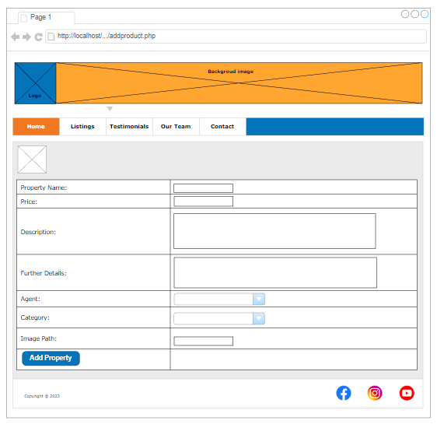

**Admin Login - http://localhost/.../adminlogin.php**

